KingsHands HandHistory Auto Downloader manual.

Contents:
- General info
- Downloading and installing AutoDownloader
- Configuring AutoDownloader
  - Configuring KingsHands account (login and password)
  - Configuring rooms and room saving options
  - Other configurations

- General Info
Main purpose of HH Auto Downloader is to automate the process of downloading, unpacking, saving and converting hand histories from www.kingshands.com website.
Program functions are:
- Checking website www.kingshands.com for handhistory updates, using your KingsHands account
- Downloading hand history to your PC
- Unpacking hand history files
- Saving hand histories accordingly to it’s type into KingsHands converter import directory or directly to HoldemManager/PokerTracker import directory if no converting needed.

- Downloading and installing AutoDownloader
AutoDownloader can be downloaded from http://kingshands.com/soft/29/ , you need to press button “Download” and save installation file to your PC. Then run installation file, follow step-by-step installer to install the software on your PC. Shortcuts for the program will appear on your desktop and in main menu.

- Configuring AutoDownloader
a) Configuring KingsHands account (login and password)
After the installation start the program. On first startup (or not first, but if you did not configure login and password) program will show you options window:
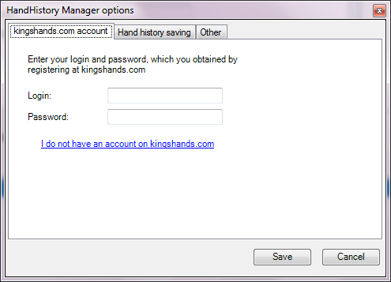
Select tab “kingshands.com account”. Enter your login and password for the www.kingshands.com website into corresponding inputs. If you do not have KingsHands accout – click hyperlink “I do not have an account on kingshands.com”, you will be redirected to registration webpage.
b) Configuring rooms and room saving options
After you configured login and password – select tab “Hand history saving”:
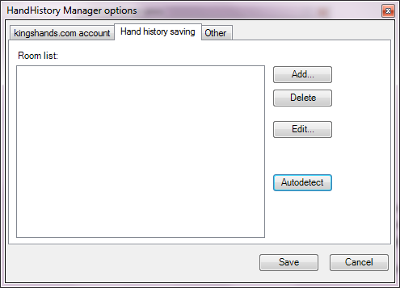
This tab helps you to identify save paths for each type of hand history. Note that you need login and password to be configured to set up save paths! You can press “Autodetect” button and program will detect available room types and will try to detect save paths. In case multiple possibilities of save path, program will show wizard which helps you to choose one of paths.
Also you can add paths manually, using button “Add…”
Note that configuring hand history saving paths requires the program to be logged in to kingshands website. This means that you must enter login and password before configuring save paths.
c) Other configurations
Go to ta “Other” of HandHistory Manager options window. Here you can configure such parameters as:
- Synchrinization period – time between two checks of hand history updates
- Run at windows startup – check this if you want the program to start at Windows startup
- Temporary download path - a path where packed hand histories are placed after they are downloaded and before they are unzipped to converter import path.
