KingsHands Aconcagua Converter Manual
This manual contain all general information you will need to use KingsHands converter
Contents:
- General information
- Downloading and installing converter
- Getting the license
- Configuring the converter:
  - Automatic configuration
  - Manual configuration
- Configuring the poker room
- Configuring the hand history manager
  - Configuring HoldemManager 1
  - Configuring HoldemManager2
  - Configuring PokerTracker 4
- Additional info
- Frequently asked questions
1. General information
KingsHands converter converts hand history from native format to PokerStars. Because HoldemManagers and PokerTracker operates only with little number of currencies, converter can rename national currencies like Russian Ruble or Argentinian Peso to any currency, supported by history managers. Converting currencies does not mean any calculations between currencies, only renaming!
2. Downloading and installing converter
Download installer package from http://kingshands.com/soft/47/. Click “Download” button, save installer package and launch it. Follow the instructions of the installer and perform step-by-step setup. After installation is complete, shortcuts of KingsHandsConverter will be created on your desktop and in “Start” menu.
3. Getting the license
Launch the program using desktop or “Start” menu shortcut. Program will show you license key dialog box.
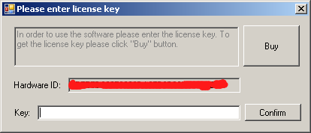
Click “Buy” button (if you already have a kingshands account) or copy “Hardware ID” and send it to Skype “kings.hands”. Technical support will help you to create account, and after payment is received will generate you a license key. Enter license key to corresponding field and press “Confirm” button.
4. Configuring the converter
Converter have some options, that have to be configured:
- Hand history folder (the path where poker room is installed)
- “Export to” folder (path, where converter stores hands in PokerStars format)
- Type of HUD
- Usage of converting prefix (renaming all players from “playername” to “PREFIX_playername”)
- Currency converting rules (renaming national currencies to one of the: {USD, EUR, GBP})

a) Automatic configuration
Hand history folder and “Export to” folder can be configured using “Autodetect” buttons.
To auto-configure Hand history folder start your poker room and press “Autodetect” button. Converter will find poker installation path.
Autodetecting of “Export to” folder depends of what hand history managers are installed. If you have one manager installed then autodetect will just find the default or one of the configured paths. If you have multiple managers installed – Autodetect will show a step by step wizard, where you can choose the right path.
Currency converting options are initialized at first startup to default values. You always can change these settings by clicking menu “Program->Currency converting options”.
b) Manual configuration
You can also manually set up converting paths. To do it use “…” buttons on the left side of path input text fields or type paths to input fields manually. Note that “Hand history folder” must be set to poker room installation folder. “Export to” folder can be any folder on your PC where you would like to save converted hands.
5. Configuring the poker room
At poker room startup you should choose one of the languages, supported by converter: English, Russian or Spanish. If you select other language hands will be converting but automatic HUD work is not guaranteed.
You also should enter “Options” menu, find hand history options (location of these options is different in poker rooms) and make sure that checkbox “Save hand history” is checked.
To enable the HUD in Windows 7 and 8, your must also configure launching of the poker application under “Administrator”. You must rightclick the poker room shortcut, then select "Properties" menu item, in properties window, you must select the tab "Compatibility" and set a checkbox on the item "Run this program as an administrator".
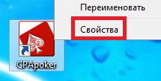
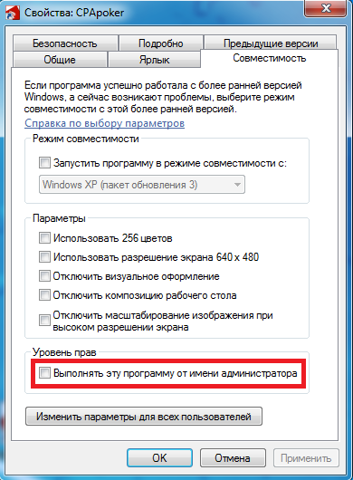

6. Configuring hand history manager
The main principle of configuring the hand history manager is that you should add to scanning configuration a path, that you set as “Export to” in converter.
a) Configuring HoldemManager 1
Launch the HoldemManager, then in the main window you should go to "Import" and click a hyperlink «Click here to add autoimport folders».
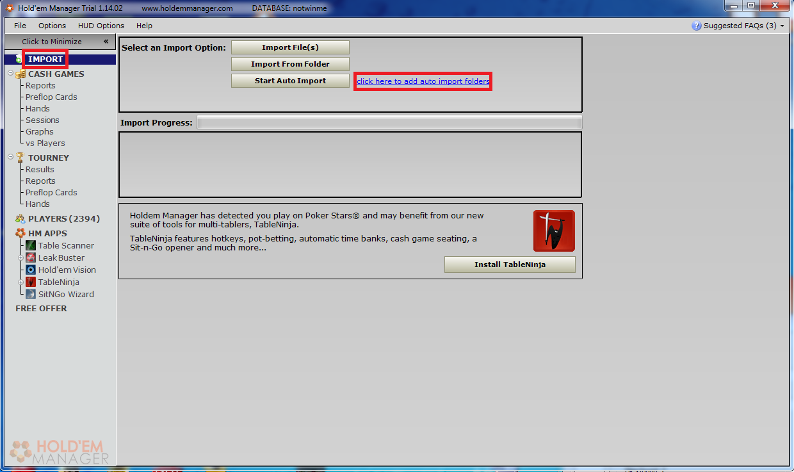
In the opened window, you should click «Add Folder», dialog window will appear. Press «Select», and select the path, you specified before as “Export to”, and then press «Save» (You should not add any new path is you previously did “Autodetect” for “Export to”)!
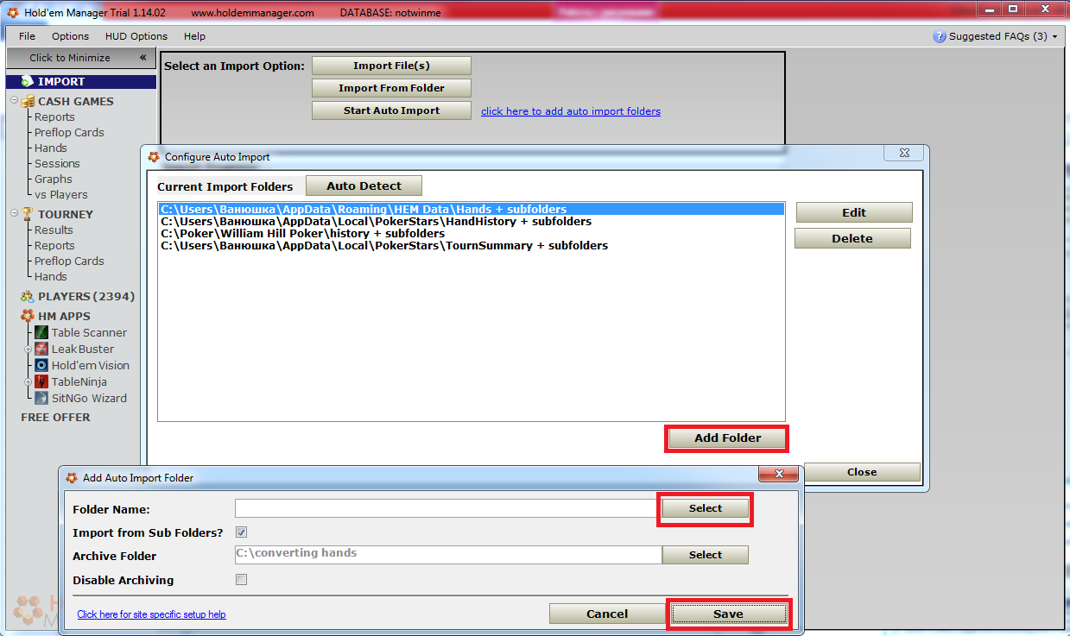
Next, you should press the button «Start auto import» in the manager, and push “Start” button in converter. Play few hands, then you should use Table Finder to specify a HUD for a table you play. Table Finder will offer to add you the name of an executable file (for example, GameClient.exe) to your list, and you should agree. After that HUD will find all the tables automatically.
b) Configuring HoldemManager 2
You should not do this if you did “Autodetect” for “Export to” folder!
Launch the HoldemManager2, then on tab «Home» select «Site setup».
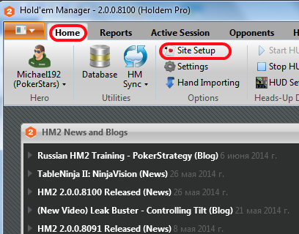
In the Setting window, select the item «PokerStars» and then press the "+" to add a new path
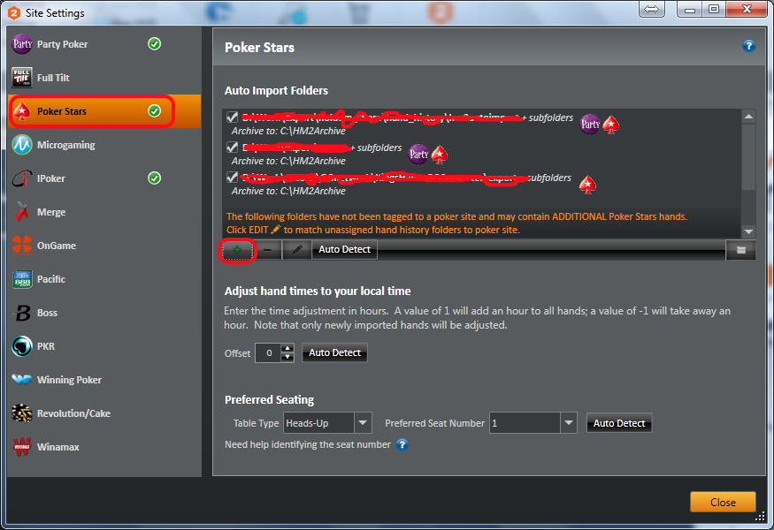
and select the folder where the converter saves the converted files
c) Configuring PokerTracker 4
Launch the PokerTracker, click on the tab "Play Poker", in the left side of the list click «Configure», in the opened configuration dialog window select the tab "Site Configuration", then in the list of poker rooms select the PokerStars, click «Add», and select the path where the converter saves the converted files.

If hand converting in PokerTracker was started when you changed the configuration - it must be restarted to apply changes.
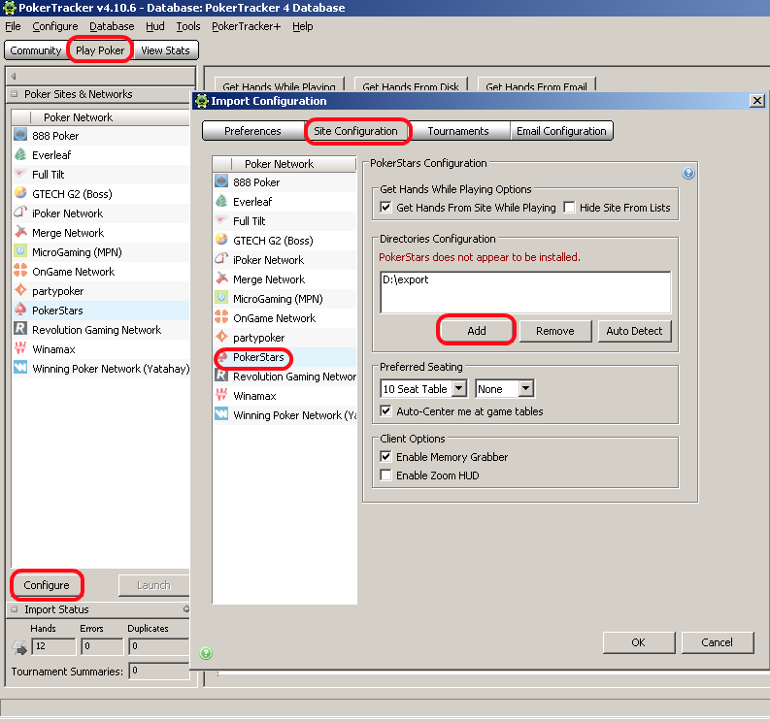

7. Additional info
Converter supports Omaha hands, tournaments, SNG’s. HUD for tournaments and SNG’s is NOT automatic, you should use table finder to find a corresponding table. Tournaments and SNG’s are supported partially, original history does not contain info about tournament buyin and rake, so converter writes fake info about buyin and rake.
1. Frequently asked questions
If converter stopped increasing found and converted counters while you play then there is a chance of HH database corruption. You need to enter “Options->Hand history options” in pokerroom, find hyperlink “Check consistency”, click it, and if program says that database have errors then click hyperlink “Repair”.
If you have problems with HUD positions – HUDS for all tables are in the top left corner of the screen – ensure that you do not use any table manager, like TableNinja or StackAndTile. Also check if you have only one KingsHandsConverter process running.

