**1.** http://license.kingshands.com/files/soft_files/29/install_pokermasterconverter_0_0_14.exe - download and install the converter. After that, provide the support service with your Hardware ID (you will see it in the first window after the converter starts). And your e-mail.  
  
**2.** In the converter in the “Settings” tab check the data, all should be like this.   
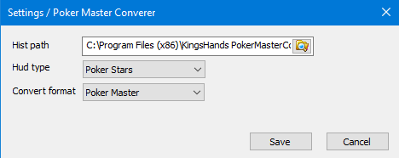

Click «save» button.  
This is the path where the converter saves hands.

3. Each emulator is configured separately. Run emulators strictly one by one! Start the converter, click Start in the converter.   
  
**4.** Start the converter, click Start in the converter. Open the emulator, in the converter in the line «Emulator Wind» the name of the running emulator should be specified: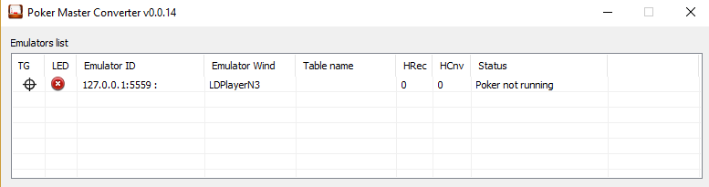The version of the PokerMaster should be the last, now 2.6.8. The status of «Poker not patched» and the button «patch poker» will appear in the converter. Click on «patch poker» and wait until the PokerMaster application is removed and installed again, the status will become «Poker not running”, and in the Actions log window there will be an inscription “CHECK PATCH END» :   
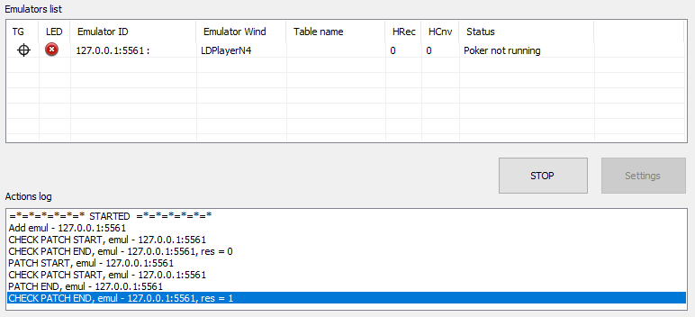  
  
**5.** In the folder where the converter is installed (by default C: \ Program Files (x86) \ KingsHands PokerMasterConverter) there should be a subfolder “hist_conv”, if it is not there, then you need to create a folder with that name.

**6.** In HМ2 in the Site setup for Asian Poker Clubs, add the path to the folder C: \ Program Files (x86) \ KingsHands PokerMasterConverter \ hist_conv:

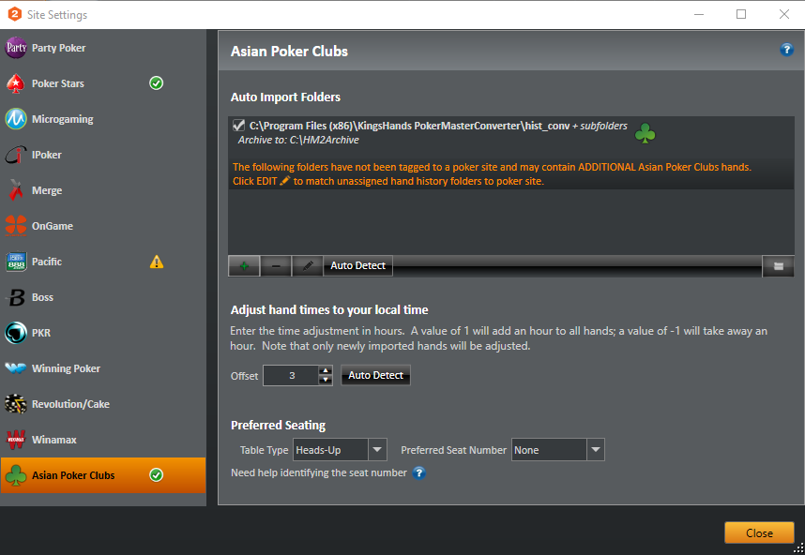

**7. Startup order:**  
7.1 Launch HM2.  
7.2 Launch converter, click start.  
7.3 Launch emulator. If there is a several emulators, then **EACH ONE SHOULD BE LAUNCHED STRICTLY TURNED**   
7.4 Open table.  
  
**IMPORTANT! ALL SOFT SHOULD BE LAUNCHED AS ADMIN!**