\* For more comfortable work in the browser, it is recommended to use external coxifiers

(permeo, proxifier, etc ...), to direct traffic to the Sox client

\* download unzip and run software

\* (skip this step if you used installer \*) if you are working with proxifier, add vip72socks.exe to the exclusion list.

\* IMPORTANT! after starting the socks client, verify that the necessary settings are set in mozilla firefox in the settings

if firefox was running at the time of installation, it must first be restarted. If the values differ from the specified ones, they must be changed manually.

to check, you need to enter about: config as a URL, then accept the warning and enter the advanced settings mode

after that, enter in the search bar on the settings and verify the values:

media.peerconnection.enabled SHOULD BE FALSE

network.http.max-connections SHOULD BE 32

network.http.max-persistent-connections-per-proxy SHOULD BE 16

\* Next, enter the username and password in the client, click the LOGIN button

\* Then you need to enter the PERSONAL token for authorization, this: db70016a84265f787f5f8f9ffb219cbb

\* click on 'select country', then using the double-click select the desired country

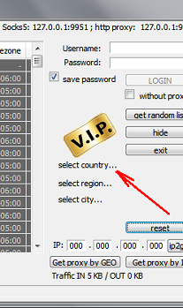

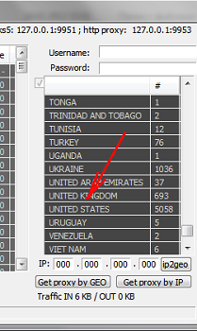

\* Now you need to click the Get by GEO button to get a list of IP for the selected location

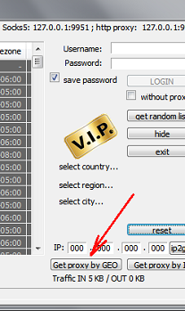

\* select the desired Sox using double click

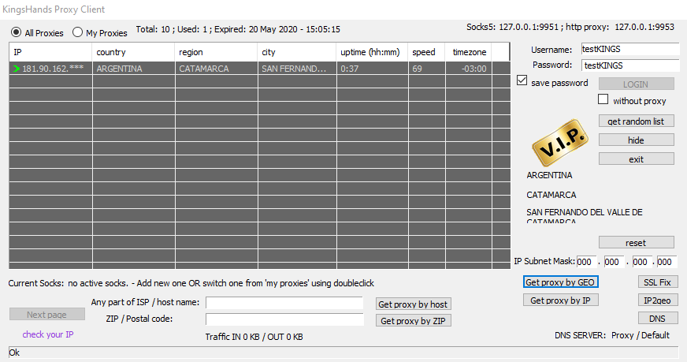

\* proxy speed value, 'speed' column; 100 - excellent; 97-99 good; 91-96 is normal; 50-90 slow (usually 3G networks, EDGE); 0-50 is very slow (usually GPRS / DIAL-UP networks)

\* if sox works, then it will be added to the 'my proxies' tab

\* you can quickly switch doubleclick between soxes on the 'my proxy' tab

\* (with manual configuration) - must be installed in your browser as socks5

127.0.0.1:9951

\* (OR if you chose the installer to install) - just start the proxy from the desktop